**Question 1**

The big difference between observational study designs and experimental study designs is the process that determines who is exposed and who isn't.

1. True
2. False

This is true. In experimental studies we assign people to be exposed (at random or otherwise). In observational studies, some other process (i.e., not us) determines who is exposed and who isn't (i.e., self-selection, the actions of others, or both).

**Question 2**

Prevalent cases (people who have the outcome of interest) should not be eligible for cohort membership.

1. True
2. False

This is true. People who have the outcome of interest at the start of the study period should not be eligible for cohort membership. The objective is to see who develops the outcome.

**Question 3**

In a traditional cohort study design, members of the cohort are selected based on their ______ status.

1. Disease
2. Exposure
3. Outcome

In a traditional cohort study design, members of the cohort are selected based on their exposure status (i.e. exposed vs. unexposed).

**Question 4**

People with diabetes should be eligible for a cohort study that seeks to estimate the effect of diet on incident diabetes?

1. True
2. False

This is False because people with diabetes are not at risk of developing incident diabetes. Diabetes is currently an incurable disease.

**Question 5**

People who have received a measles vaccination should be included in a cohort study that seeks to understand development of measles?

1. True
2. False

This one is a little trickier. Not every person who receives a vaccination is completely immune to the disease (this is one reason why herd immunity is so important). If the person is completely immune, then they are not at risk for measles, but how can we know whether the vaccine conferred complete immunity or not? In this case, most people would exclude vaccinated individuals from cohort membership. However, doing so may exclude some individuals who are at risk.

**Question 6**

In a cohort being studied for occurrence of breast cancer, should men be considered part of the population at risk?

This one is also a little tricky. Men do develop breast cancer, but it is rare compared with its occurrence in women. One solution is to distinguish male and female breast cancer as different diseases. In that case, if female breast cancer is being studied, men would be excluded from the population at risk.

**Question 7**

What type of cohort is represented in this chart?

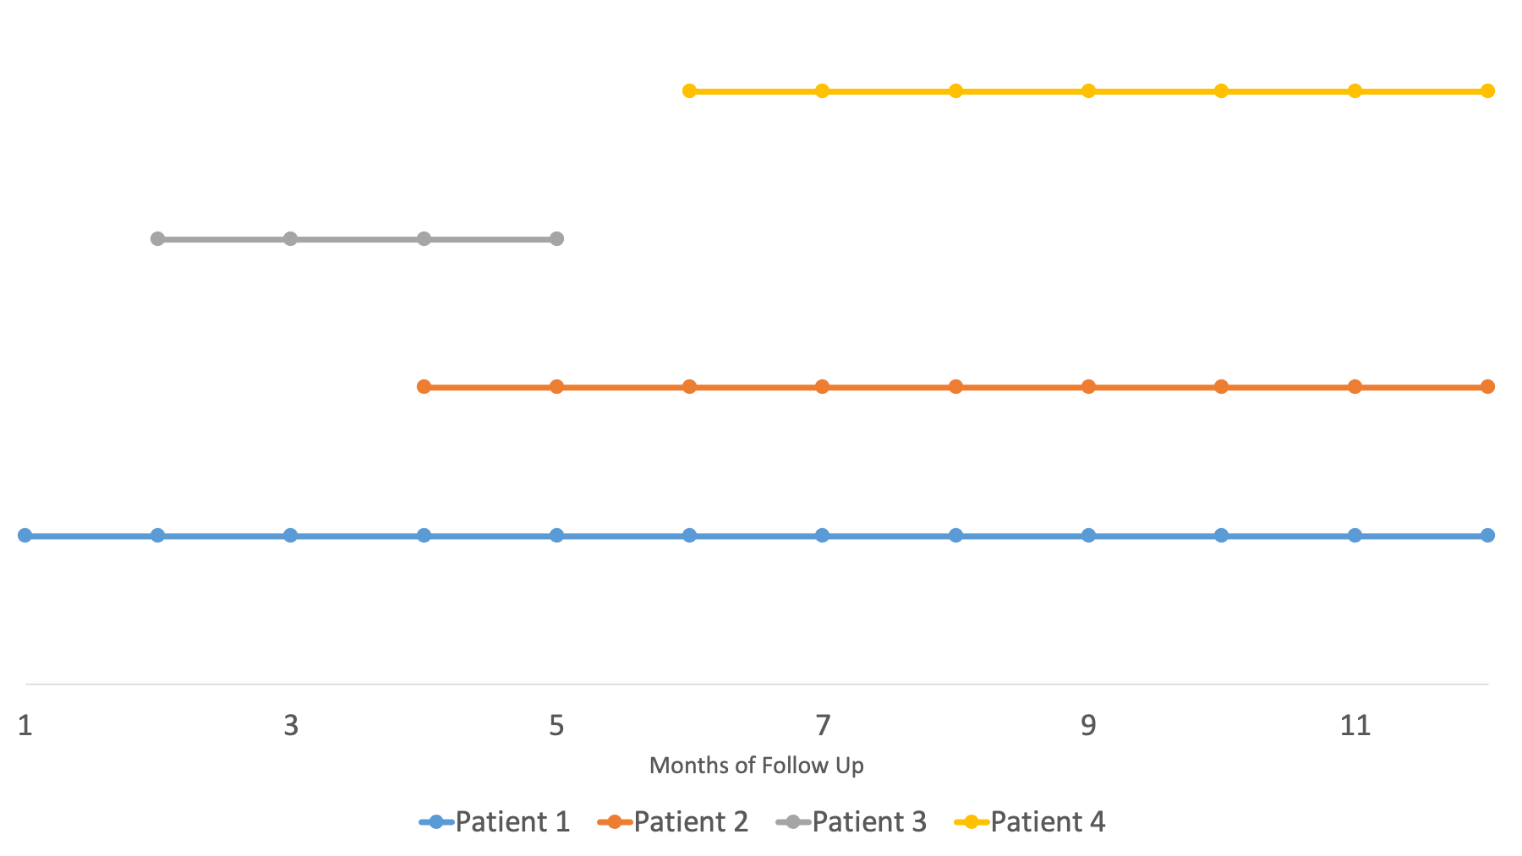

1. Fixed cohort
2. Closed cohort
3. Open/dynamic cohort

This chart represents an open/dynamic cohort. Members leave and are added over time.

**Question 8**

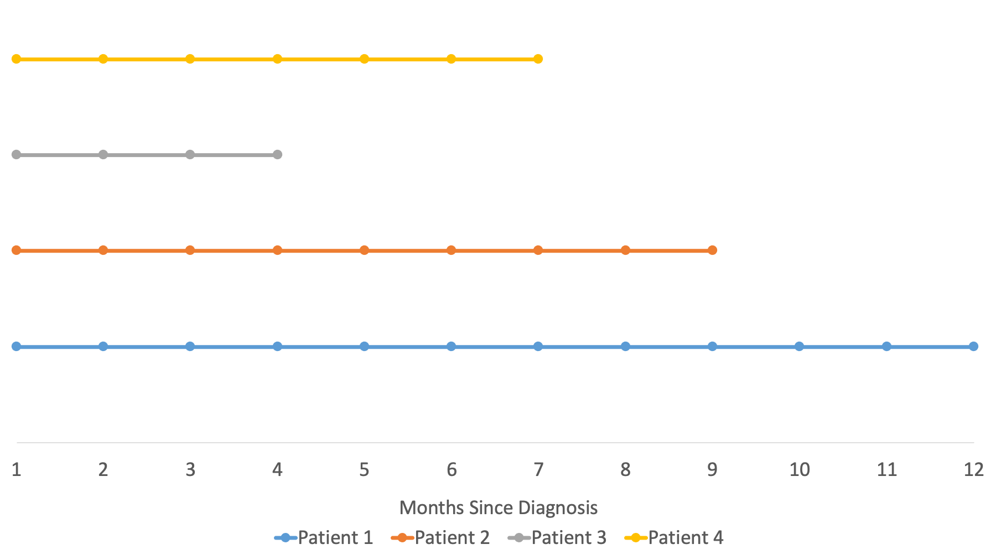

1. Fixed cohort
2. Closed cohort
3. Open/dynamic cohort

This chart represents an open/dynamic cohort. Exposure groups are defined at the beginning of the study and there is no movement between exposure groups. However, there is loss to follow-up.

**Question 9**

Which cohort study design enrolls participants at the beginning of the study and follows them into the future?

1. Prospective cohort study
2. Retrospective cohort study
3. Mixed design cohort study

The prospective cohort study enrolls participants at the beginning of the study and follows them into the future.

**Question 10**

Let’s say that I smoked a cigarette for the first time yesterday, you enrolled me in your cohort today, and I am diagnosed with lung cancer tomorrow. If your study is investigating the relationship between smoking and lung cancer, should I be included as an incident case?

1. Yes
2. No

This is admittedly an extreme example, but most epidemiologists would say that the answer is no. We are trying to understand the relationship between smoking and lung cancer. Given what we know about the natural history of lung cancer, there is basically zero probability that smoking was a component cause of this particular case of lung cancer. Therefore, it provides no relevant information about the exposure-outcome relationship that we are interested in. In this case, I probably had preclinical lung cancer at the time I was enrolled.